1.

package assignmentonejava;

import java.util.Arrays;

import static java.util.Arrays.*binarySearch*;

// Write a program that will find your key is found in the given array using binary search method

// numbers=[1,6,9,3,5,4,7], Key=5

public class BinarySearchMethod {

public static void binarySearch(int arr[], int first, int last, int key){

int mid = (first + last)/2;

while( first <= last ){

if ( arr[mid] < key ){

first = mid + 1;

}else if ( arr[mid] == key ){

System.*out*.println("Element is found at index: " + mid);

break;

}else{

last = mid - 1;

}

mid = (first + last)/2;

}

if ( first > last ){

System.*out*.println("Element is not found!");

}

}

public static void main(String args[]){

int arr[] = {1,6,9,3,5,4,7};

int key = 5;

int last=arr.length-1;

*binarySearch*(arr,0,last,key);

}

}

**Output:**

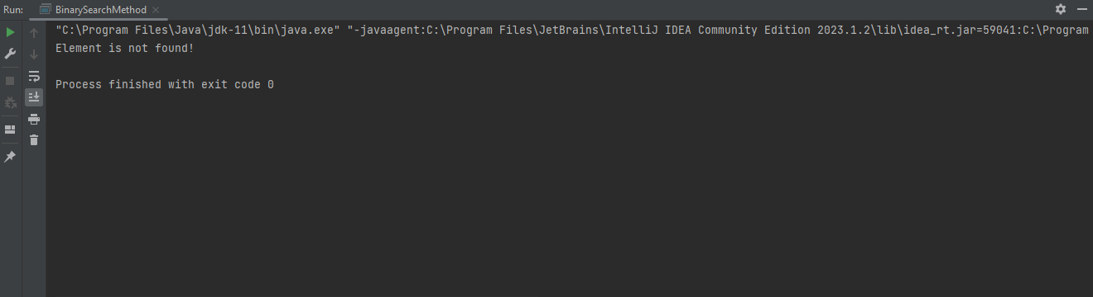

2.

package assignmentonejava;

import java.util.Scanner;

// Write a program that will breakdown the amount and count notes for any given amount. Here is the notes in the given array:

// notes=[1000,500,200,100,50,20,10,5,2,1]

public class BreakdownAmountCashNote {

public static void main(String[] args) {

Scanner input = new Scanner(System.*in*);

System.*out*.println("Enter the Amount: ");

int number = input.nextInt();

int nt1000, nt500, nt200, nt100, nt50, nt20, nt10, nt5, nt2, nt1;

nt1000 = nt500 = nt100 = nt200 = nt50 = nt20 = nt10 = nt5 = nt2 = nt1 = 0;

if (number >= 1000)

nt1000 = number / 1000;

number -= nt1000 * 1000;

if (number >= 500)

nt500 = number / 500;

number -= nt500 * 500;

if (number >= 200)

nt200 = number / 200;

number -= nt200 * 200;

if (number >= 100)

nt100 = number / 100;

number -= nt100 * 100;

if (number >= 50)

nt50 = number / 50;

number -= nt50 * 50;

if (number >= 20)

nt20 = number / 20;

number -= nt20 * 20;

if (number >= 10)

nt10 = number / 10;

number -= nt10 * 10;

if (number >= 5)

nt5 = number / 5;

number -= nt5 * 5;

if (number >= 2)

nt2 = number / 2;

number -= nt2 * 2;

if (number >= 1)

nt1 = number;

System.*out*.println("Total Number of Notes");

System.*out*.println("1000 = " + nt1000);

System.*out*.println("500 = " + nt500);

System.*out*.println("200 = " + nt200);

System.*out*.println("100 = " + nt100);

System.*out*.println("50 = " + nt50);

System.*out*.println("20 = " + nt20);

System.*out*.println("10 = " + nt10);

System.*out*.println("5 = " + nt5);

System.*out*.println("2 = " + nt2);

System.*out*.println("1 = " + nt1);

}

}

**Output:**

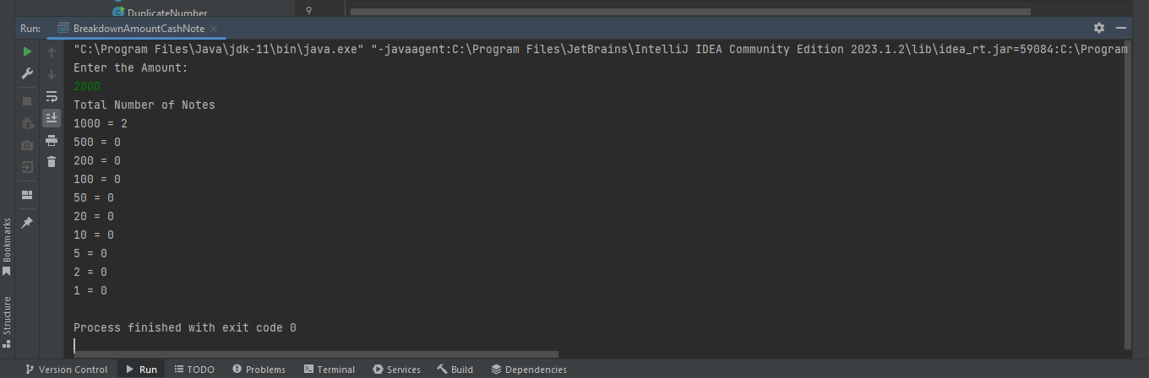

**3.**

**package assignmentonejava;**

**// Count number of words, number of characters without spaces, number of vowels and consonant from the given string:**

**// "I live in Bangladesh"**

**public class CountWordsCharVowCons {**

**public static void main(String[] args) {**

**String str = "I live in Bangladesh";**

**int vowels = 0, consonants = 0, digits = 0, spaces = 0;**

**int sum;**

**int whitespace;**

**str = str.toLowerCase();**

**for (int i = 0; i < str.length(); i++) {**

**char ch = str.charAt(i);**

**if (ch == 'a' || ch == 'e' || ch == 'i' || ch == 'o' || ch == 'u') {**

**vowels++;**

**} else if ((ch >= 'a' && ch <= 'z')) {**

**consonants++;**

**} else if (ch >= '0' && ch <= '9') {**

**digits++;**

**} else if (ch == ' ') {**

**spaces++;**

**}**

**}**

**sum = vowels+consonants;**

**whitespace= spaces+1;**

**System.*out*.println("Vowels: " + vowels);**

**System.*out*.println("Consonants: " + consonants);**

**System.*out*.println("Digits: " + digits);**

**System.*out*.println("White spaces: " + spaces);**

**System.*out*.println("Total word: " + whitespace);**

**System.*out*.println(sum);**

**Output:**

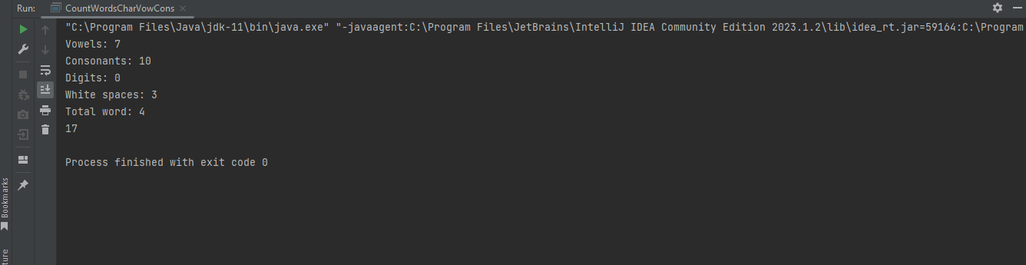

**4.**

**package assignmentonejava;**

**// Find out the duplicate numbers in the given array and in which position they are found.**

**// numbers= [1,2,3,1,2,4,5,6,4]**

**public class DuplicateNumber {**

**public static void main(String[] args) {**

**int numbers[] ={1,2,3,1,2,4,5,6,4};**

**System.*out*.println("Duplicate elements are: ");**

**for (int i=0; i< numbers.length; i++){**

**for (int j=i+1; j< numbers.length; j++){**

**if (numbers[i] == numbers[j]){**

**System.*out*.println(numbers[j]);**

**}**

**}**

**}**

**}**

**}**

**Output:**

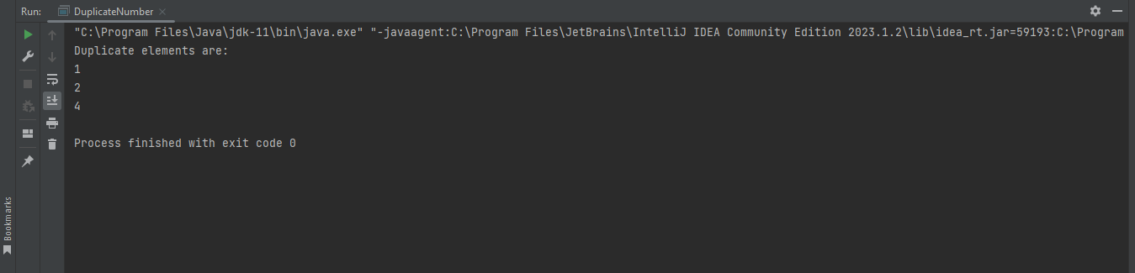

**5.**

**package assignmentonejava;**

**// Encrypt word: ROADTOSDET [when A=F]**

**public class EncryptWord {**

**public static void main(String[] args) {**

**String name = "ROADTOSDET";**

**String encryptedtext = *encrypt*(name);**

**System.*out*.println("Encryptedtext: " + encryptedtext);**

**}**

**public static String encrypt(String plaintext) {**

**StringBuilder encryptedText = new StringBuilder();**

**for (int i = 0; i < plaintext.length(); i++) {**

**char currentChar = plaintext.charAt(i);**

**if (Character.*isLetter*(currentChar)) {**

**char encryptedChar = (char) (currentChar + 5); // Adding 5 to each character**

**if (encryptedChar > 'Z') {**

**encryptedChar = (char) (encryptedChar - 26); // Wrap around to 'A' if it exceeds 'Z'**

**}**

**encryptedText.append(encryptedChar);**

**} else {**

**encryptedText.append(currentChar); // Append non-alphabetic characters as is**

**}**

**}**

**return encryptedText.toString();**

**}**

**}**

**Output:**

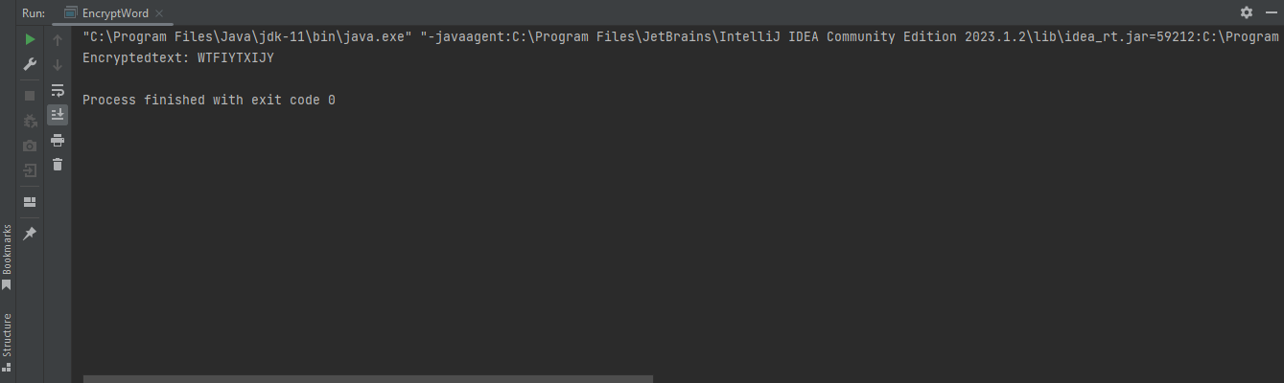

**6.**

**package assignmentonejava;**

**// Write a program that will find your key is found in the given array using linear search method**

**// numbers=[1,6,9,3,5,4,7], Key = 5**

**public class LinearSearchMethod {**

**public static void main(String[] args) {**

**int i, key=5;**

**int numbers[]={1,6,9,3,5,4,7};**

**for (i= 0; i < numbers.length; i++)**

**{**

**if (numbers[i] == key) {**

**System.*out*.println(key+" is present at location "+(i));**

**break;**

**}**

**}**

**if (i == numbers.length)**

**System.*out*.println(key + " doesn't exist in array.");**

**}**

**}**

**Output:**

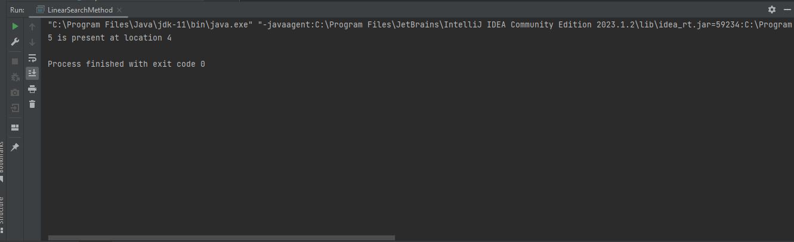

**7.**

**package assignmentonejava;**

**// Write a program that will give following output:**

**// 1**

**// 12**

**// 123**

**// 1234**

**// 12345**

**public class NumberAscending {**

**public static void main(String[] args) {**

**for (int i = 1; i <= 5; i++) {**

**for (int j = 1; j <= i; j++) {**

**System.*out*.println(j);**

**}**

**System.*out*.println();**

**}**

**}**

**}**

**Output:**

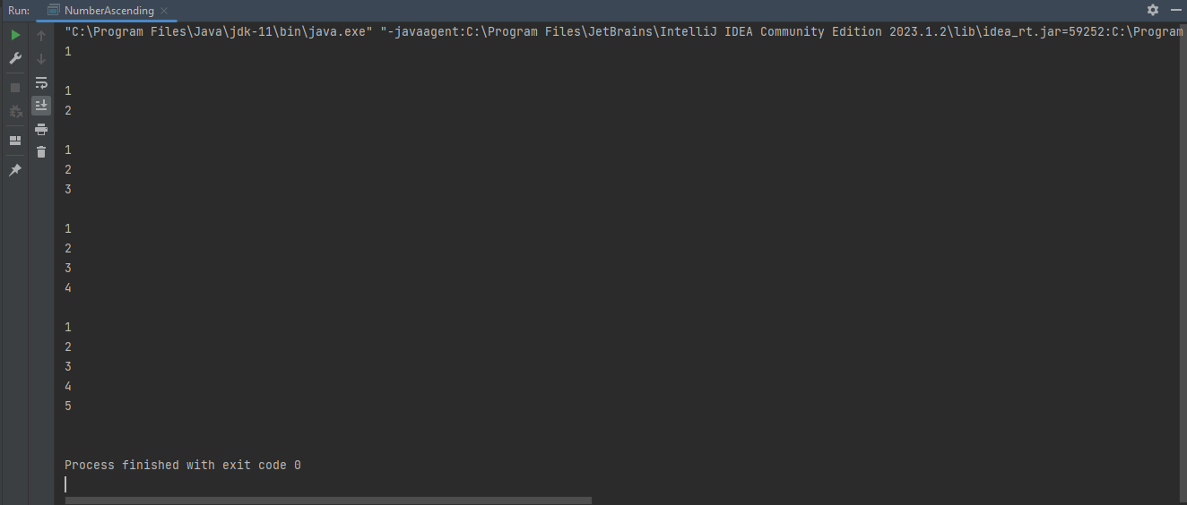

**8.**

**package assignmentonejava;**

**// Write a program that will give following output:**

**// 12345**

**// 2345**

**// 345**

**// 45**

**// 5**

**public class NumberDescending {**

**public static void main(String[] args) {**

**int rows = 5;**

**for (int i = 0; i < rows; i++) {**

**for (int j = i + 1; j <= rows; j++) {**

**System.*out*.print(j);**

**}**

**System.*out*.println();**

**}**

**}**

**}**

**Output:**

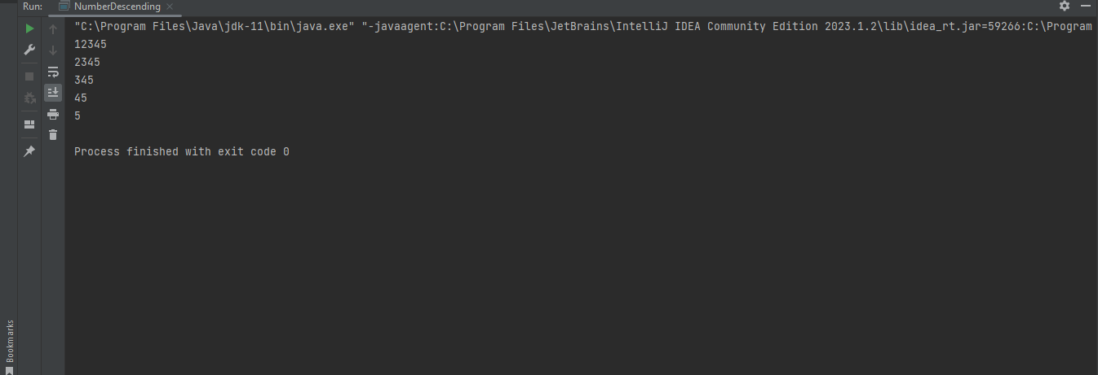

**9.**

**package assignmentonejava;**

**// Check if the given string is palindrome or not. Palindrome means after reversing a string, it will be same.**

**// Input: Civic**

**// Output: true**

**// Input: One**

**// Output: false**

**public class Palindrome {**

**public static void main(String[] args) {**

**//String str = "one", reverseStr = "";**

**String str = "civic", reverseStr = "";**

**int strLength = str.length();**

**for (int i = (strLength - 1); i >= 0; --i) {**

**reverseStr = reverseStr + str.charAt(i);**

**}**

**if (str.toLowerCase().equals(reverseStr.toLowerCase())) {**

**System.*out*.println("True");**

**} else {**

**System.*out*.println("False");**

**}**

**}**

**}**

**Output:**

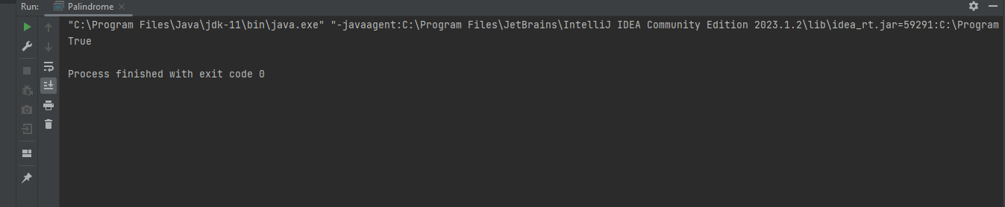

**10.**

**package assignmentonejava;**

**// Print the prime numbers of 2 to 100**

**public class PrimeNumberTwoToHundred {**

**public static void main(String[] args) {**

**int i, j;**

**for (i=2; i<=200; i++){**

**for (j=2; j<i; j++){**

**if (i % j == 0)**

**break;**

**}**

**if (i == j){**

**System.*out*.println(i);**

**}**

**}**

**}**

**}**

**Output:**

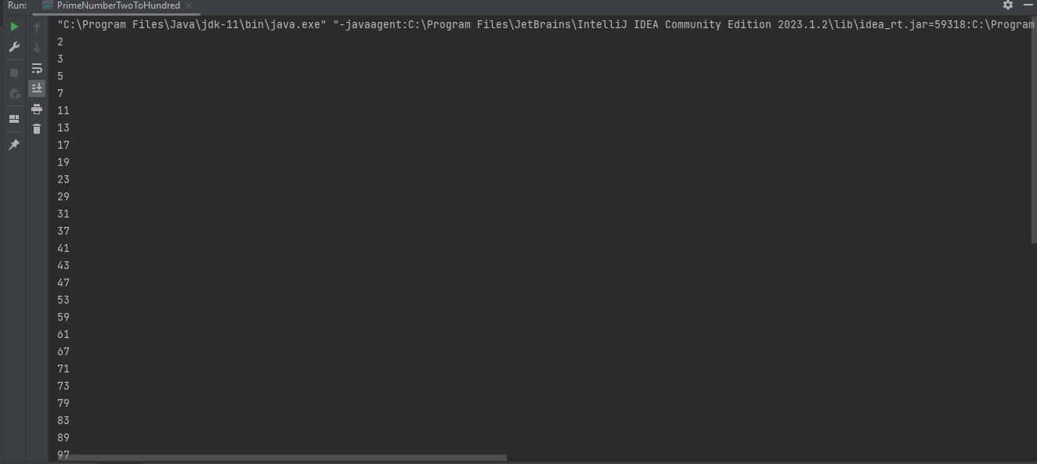

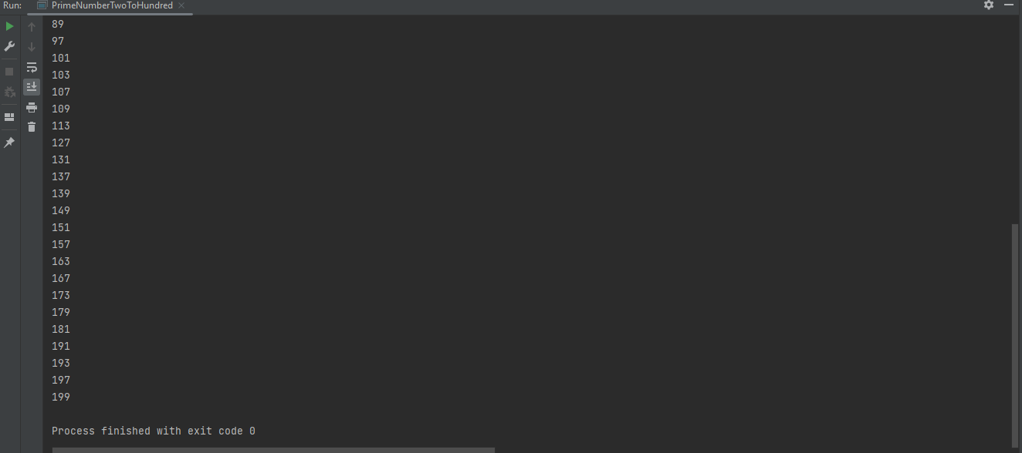

**11.**

**package assignmentonejava;**

**import java.util.Arrays;**

**import java.util.Random;**

**// Generate random 10 integer numbers in an array and print out all the numbers from array and also print the max**

**// and min number from the array**

**public class RandomMaxMinNumber {**

**public static void main(String[] args) {**

**int[] numbers = *generateRandomNumbers*(10);**

**System.*out*.println("Generated Numbers: " + Arrays.*toString*(numbers));**

**int maxNumber = *findMaxNumber*(numbers);**

**System.*out*.println("Maximum Number: " + maxNumber);**

**int minNumber = *findMinNumber*(numbers);**

**System.*out*.println("Minimum Number: " + minNumber);**

**}**

**public static int[] generateRandomNumbers(int count) {**

**int[] numbers = new int[count];**

**Random random = new Random();**

**for (int i = 0; i < count; i++) {**

**numbers[i] = random.nextInt();**

**}**

**return numbers;**

**}**

**public static int findMaxNumber(int[] numbers) {**

**int max = Integer.*MIN_VALUE*;**

**for (int number : numbers) {**

**if (number > max) {**

**max = number;**

**}**

**}**

**return max;**

**}**

**public static int findMinNumber(int[] numbers) {**

**int min = Integer.*MAX_VALUE*;**

**for (int number : numbers) {**

**if (number < min) {**

**min = number;**

**}**

**}**

**return min;**

**}**

**}**

**Output:**

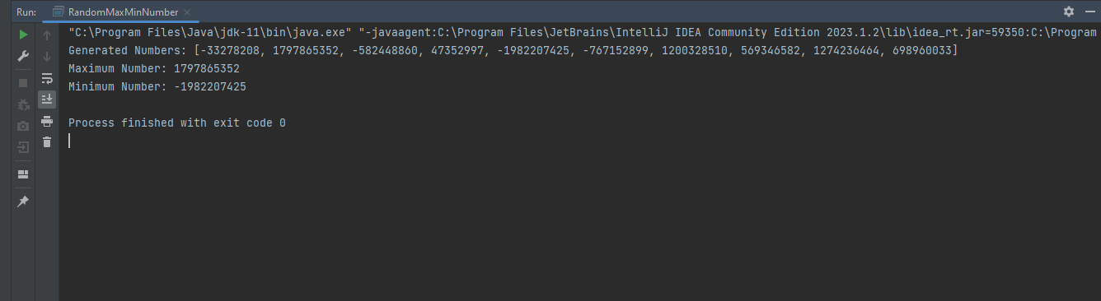

**12.**

**package assignmentonejava;**

**// Take any number as input and print the reverse of the number**

**// input: 12345**

**public class ReverseNumber {**

**public static void main(String[] args) {**

**int numbers = 12345;**

**int reverse = 0;**

**while(numbers!=0){**

**int remaining = numbers%10;**

**numbers = numbers/10;**

**reverse = reverse*10+remaining;**

**}**

**System.*out*.println(reverse);**

**}**

**}**

**Output:**

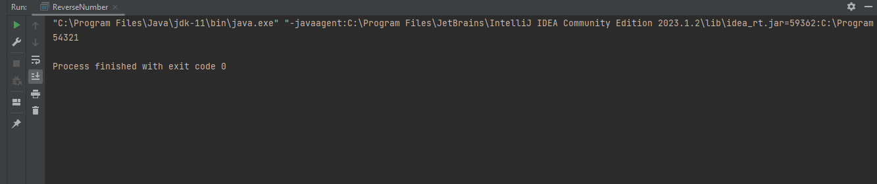

**13.**

**package assignmentonejava;**

**// Find out the second largest element of the given array**

**// numbers=[5,3,9,7,4,1,8]**

**public class SecondLargestNumber {**

**public static void main(String[] args) {**

**int largest = 0;**

**int secondLargest = 0;**

**int numbers[] = {5,3,9,7,4,1,8};**

**for (int i=0; i<numbers.length; i++){**

**if (numbers[i]>largest){**

**secondLargest = largest;**

**largest = numbers[i];**

**} else if (numbers[i]>secondLargest) {**

**secondLargest = numbers[i];**

**}**

**}**

**System.*out*.println("The second largest Number is: "+ secondLargest);**

**}**

**}**

**Output:**

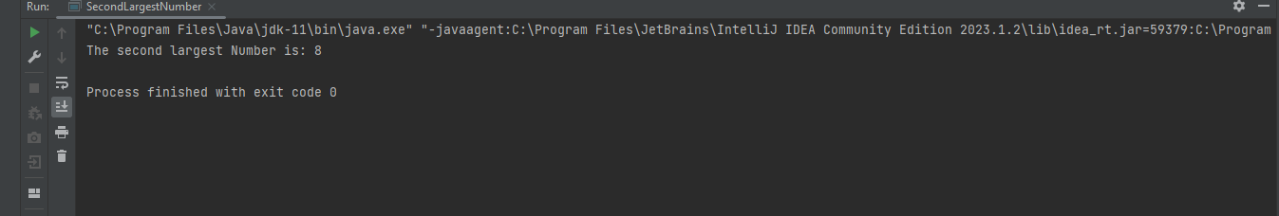

**14.**

**package assignmentonejava;**

**import java.util.ArrayList;**

**import java.util.Collections;**

**// Write a program that will shuffle (values will randomly change their position) from the given array**

**// numbers=[1,2,3,4,5,6,7,8,9,0]**

**public class ShuffleNumbersArray {**

**public static void main(String[] args) {**

**ArrayList<String> mylist = new ArrayList<String>();**

**mylist.add("1");**

**mylist.add("2");**

**mylist.add("3");**

**mylist.add("4");**

**mylist.add("5");**

**mylist.add("6");**

**mylist.add("7");**

**mylist.add("8");**

**mylist.add("9");**

**mylist.add("0");**

**System.*out*.println("Original List : \n" + mylist);**

**Collections.*shuffle*(mylist);**

**//System.out.println("\nShuffled List : \n" + mylist);**

**System.*out*.println("shuffle list: " + mylist);**

**}**

**}**

**Output:**

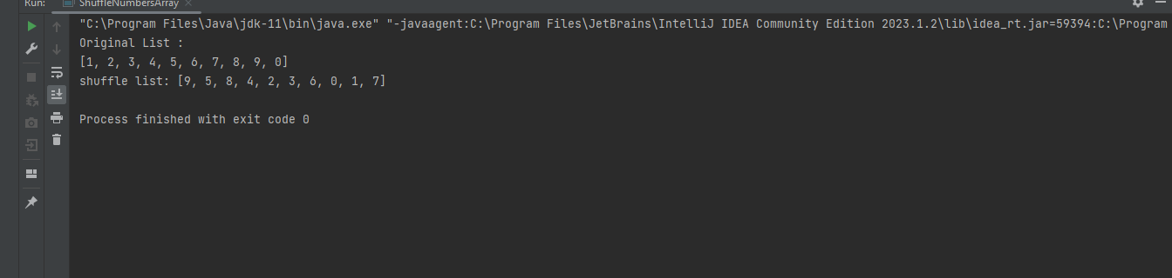

**15.**

**package assignmentonejava;**

**import java.util.Scanner;**

**// Write a program that will take integer numbers as user input continuously and print the sum of numbers until**

**// user input q from the keyboard. When user input q, program will be quit. If user inputs another character,**

**// then the program will ask to input the number again.**

**public class SumOfInputsTillQ {**

**public static void main(String[] args) {**

**Scanner input = new Scanner(System.*in*);**

**System.*out*.println("Give numbers: ");**

**int sum = 0;**

**char ch;**

**while (true){**

**int numbers = input.nextInt();**

**sum = sum+numbers;**

**System.*out*.println(sum);**

**System.*out*.println("Do you want to continue?");**

**ch = input.next().charAt(0);**

**if (ch == 'q'){**

**break;**

**}**

**}**

**}**

**}**

**Output:**

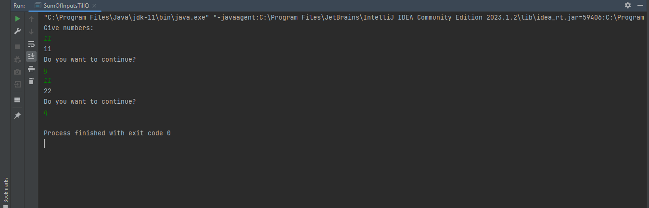

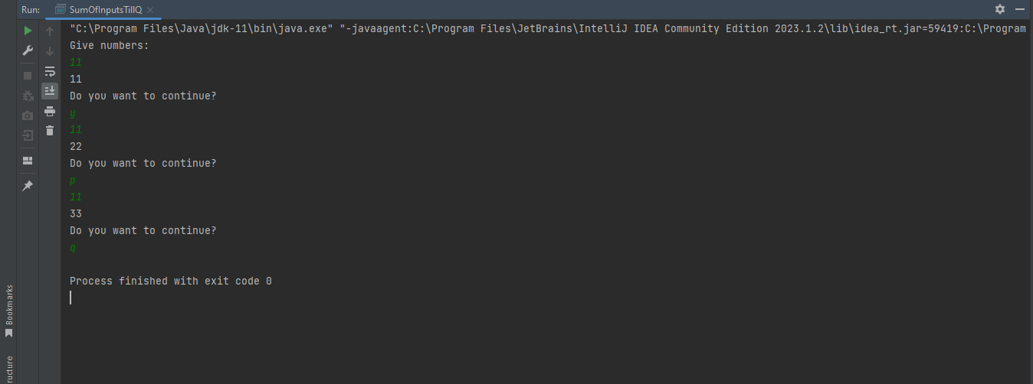

**16.**

**package assignmentonejava;**

**// Suppose, a=10 and b=20. Now swap the value using a temp variable.**

**public class SwapUsingTempVariable {**

**public static void main(String[] args) {**

**int a =10;**

**int b =20;**

**System.*out*.println("Before swap a "+a+" b "+b);**

**int temp;**

**temp=a;**

**a=b;**

**b=temp;**

**System.*out*.println("After swap a "+a+" b "+b);**

**}**

**}**

**Output:**

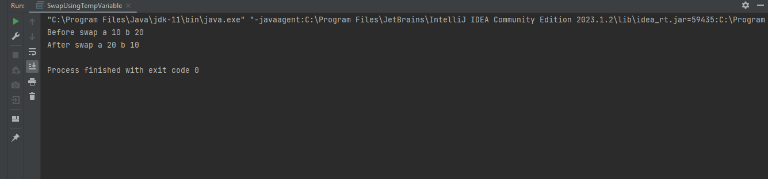

**17.**

**package assignmentonejava;**

**// Suppose, a=10 and b=20. Now swap the value without a temp variable.**

**public class SwapWithoutTempVariable {**

**public static void main(String[] args) {**

**int a = 10;**

**int b = 20;**

**a = a+b;**

**b = a-b;**

**a = a-b;**

**System.*out*.println(a);**

**System.*out*.println(b);**

**}**

**}**

**Output:**

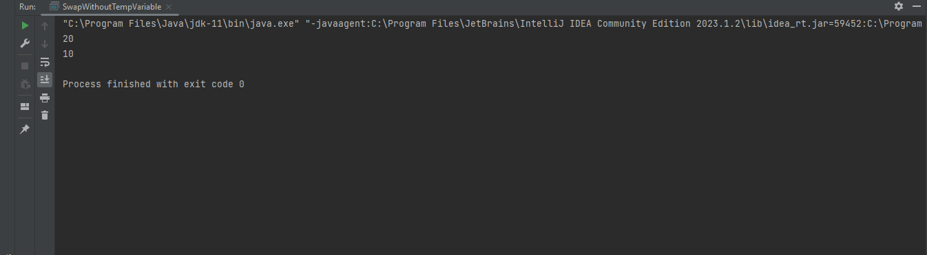

**18.**

**package assignmentonejava;**

**import java.util.Scanner;**

**// A core i 7 laptop price is 85000 tk and a gaming mouse price is 2500 tk. If I buy the laptop and 1 piece mouse,**

**// what will be my total cost after giving 15% discount? [Extract the digits from the paragraph and calculate**

**// the price]**

**public class TotalCostAfterDiscount {**

**public static void main(String[] args) {**

**//int x, y, sum, tot, fin;**

**Scanner input = new Scanner(System.*in*);**

**System.*out*.print("core i 7 laptop price is tk: ");**

**int x = input.nextInt();**

**System.*out*.print("gaming mouse price tk: ");**

**int y = input.nextInt();**

**int sum = *sum*(x, y);**

**System.*out*.println("Total cost without discount: " + sum);**

**int total = sum / 100 * 15;**

**System.*out*.println(" discount 15% tk: " + total);**

**int overall = sum - total;**

**System.*out*.println("Final amount tk: " + overall);**

**}**

**//method that calculates the sum**

**public static int sum(int a, int b) {**

**int sum = a + b;**

**return sum;**

**}**

**}**

**Output:**

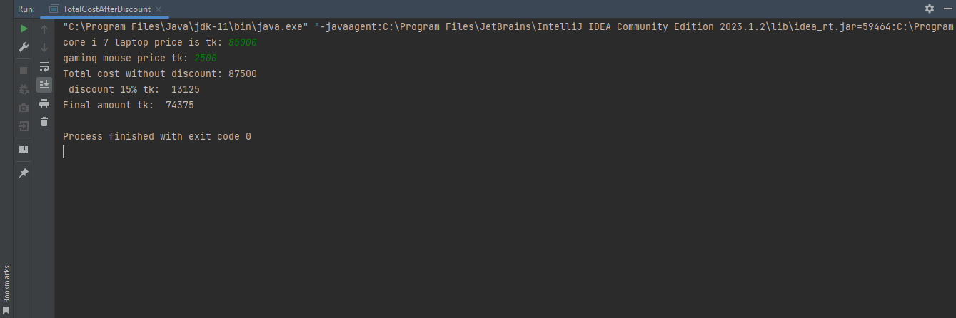

**19.**

**package assignmentonejava;**

**import java.text.DecimalFormat;**

**//Suppose a=15.5276. print the value upto 2 decimal point.**

**public class UptoTwoDecimalPoint {**

**public static void main(String[] args) {**

**double a =15.5273;**

**DecimalFormat df= new DecimalFormat("#0.00");**

**System.*out*.println("Value upto 2 decimal points: "+ df.format(a));**

**}**

**}**

**Output:**

